

Website & Design

Development

2) Design Document

**Design Document**

2.1 client and user requirements.

Website Goals:

The aim of this website is to help patients who have problems with their eyesight to see the services offered by the clinic and the specialist doctors and then reserve(book) an appointment so that they don’t have to wait for a long time in the clinic. They can also postpone, change, or cancel their appointment. Other goals in my website are that users can view appointments, login, sign up and logout.

Scope:

First, the user gets into the homepage of the website and looks at the services offered by the clinic by choosing the services link. If he finds any of the service that he is looking for, he can create or open an account. Then, he will see the specialist doctors and the schedule of each doctor and then choose a suitable appointment for him. Later, the user can view, edit and cancel the appointment.

Requirements:

Requirement 1:

The user can login and sign up the website. Also, the website allows the user to book an appointment by choosing the date and time and the user can edit or cancel this appointment.

Requirement 2:

the website allows the user to choose from the specialist doctors and the cost of the treatment session and how much time you may need to wait.

2.2 Sitemap and medium-fidelity wireframe.

Sitemap:

Wireframe:

1. mobile phone

Page 1: Home page

Page 2: login

Page 3: Sign up

Page 4: services

Page 5: booking

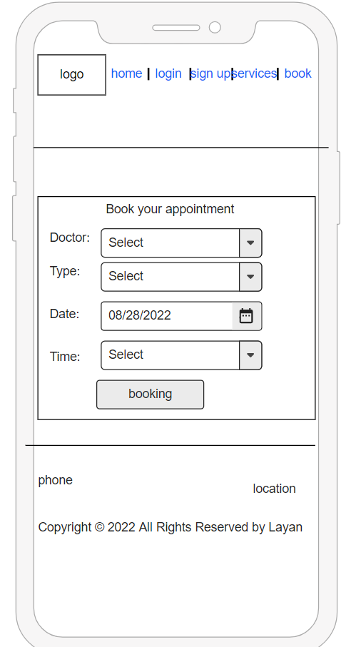

Page 6: view all appointments

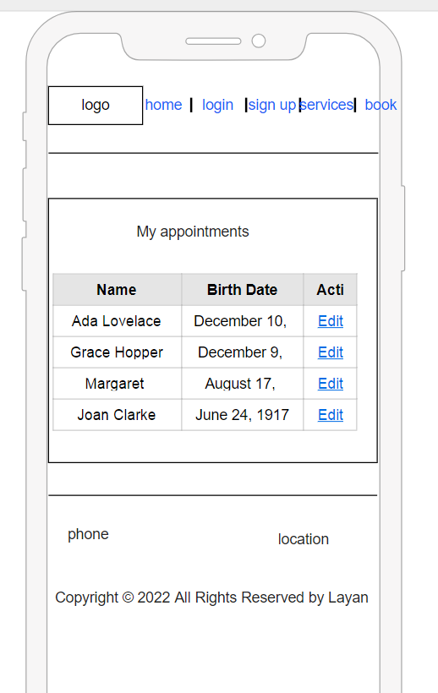

Page 7: view one appointment

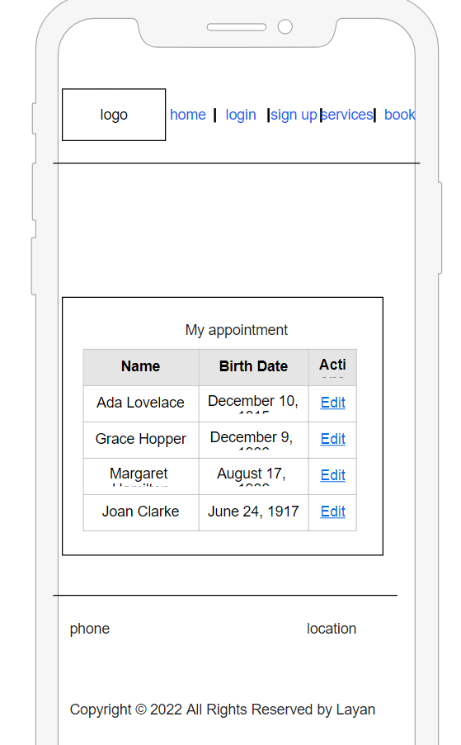

Page 8: Edit

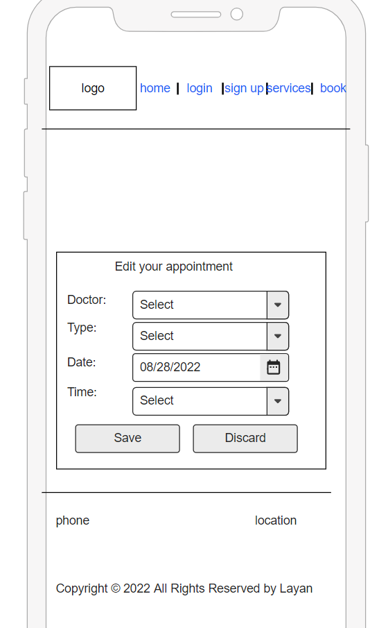

Page 9: delete

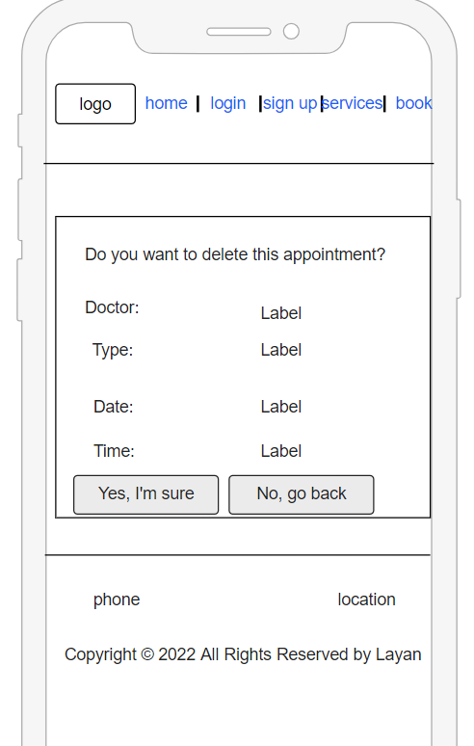

1. Laptop

Page 1: Home page

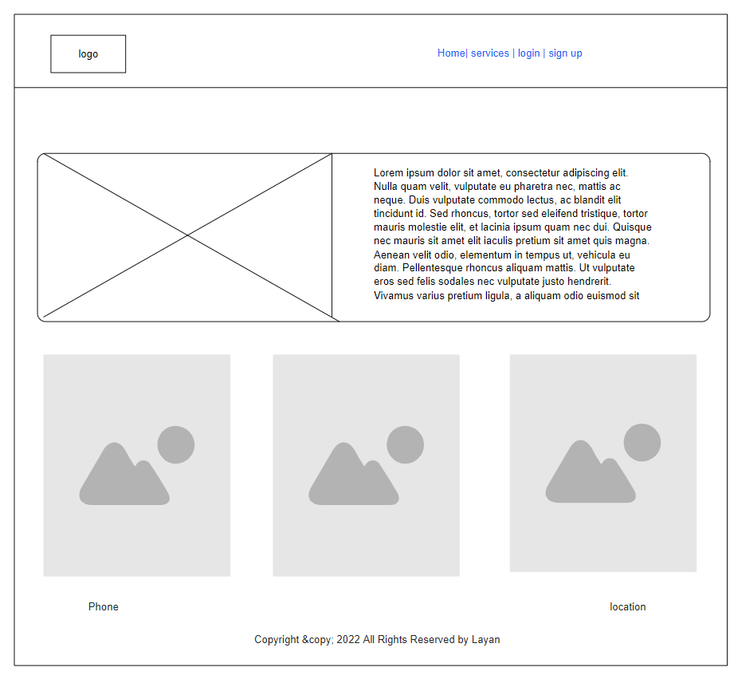

Page 2: Login

Page 3: sign up

Page 4: services

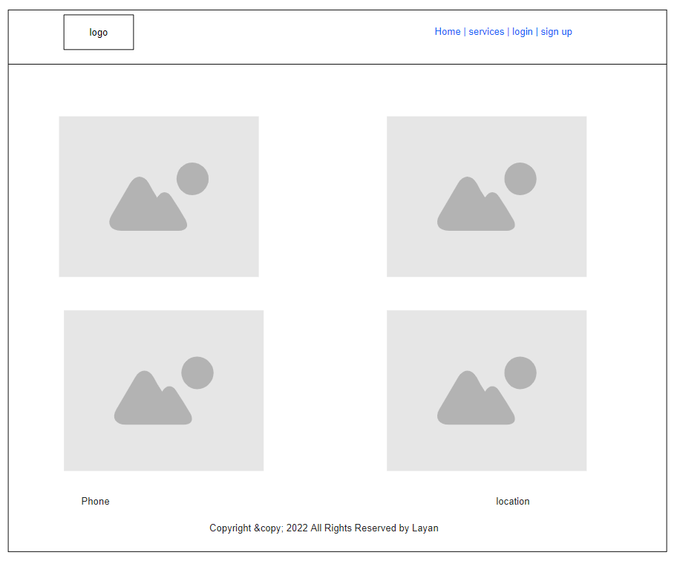

Page 5: booking

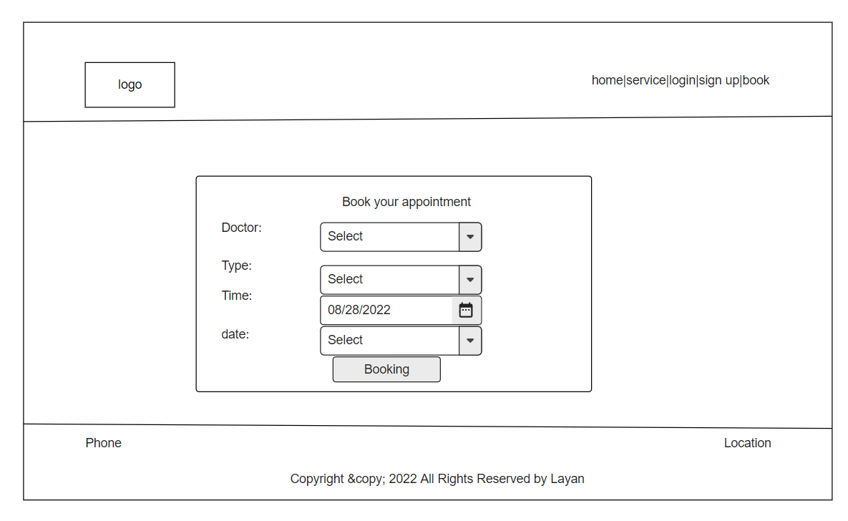

Page 6: view all appointments

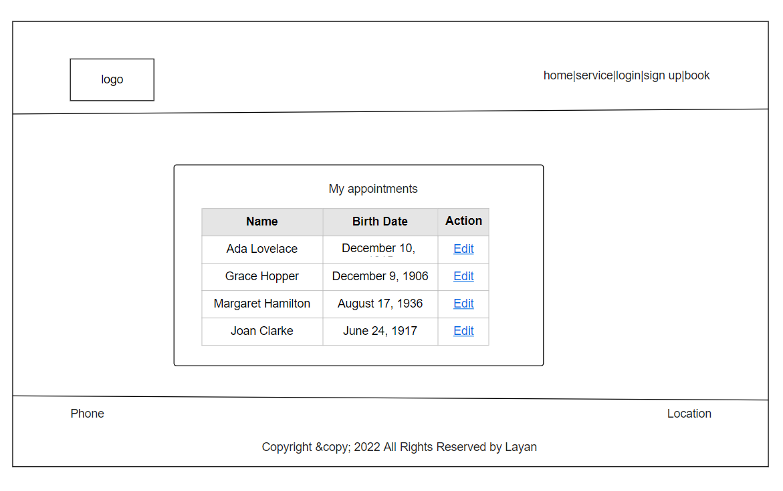

Page 7: view one appointment

Page 8: Edit

Page 9: delete

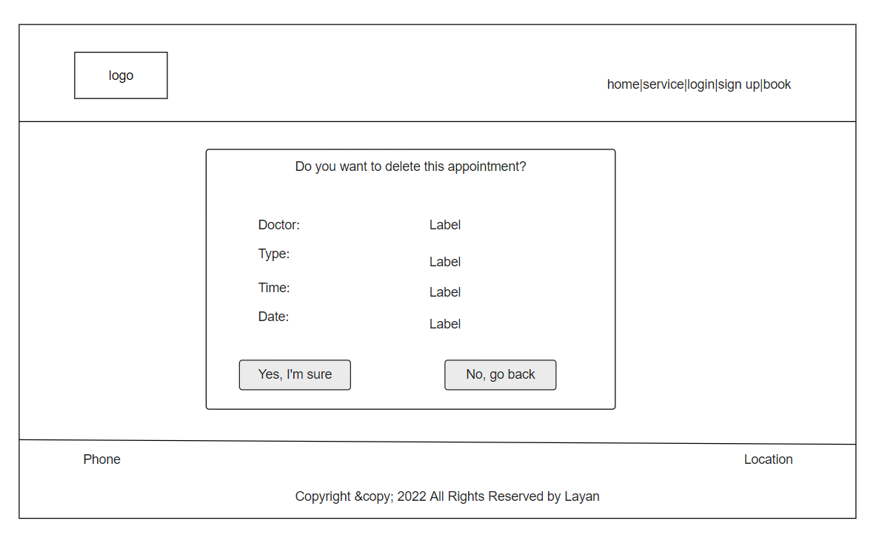

Wireframe elements:

|  |  |  |  |
| --- | --- | --- | --- |
| No | name | type | Description |
| 1 | logo | image | Describe website title |
| 2 | login | button | Enter the website and redirect to home page |
| 3 | Sign up | button | Redirect to login page |
| 4 | logout | link | To leave the website and redirect to home page |
| 5 | booking | button | Add appointment to database and to my appointments page |
| 6 | Main menu | Nav bar | Menu that contains many links lead to website pages |
| 7 | cart | div | Div which contains many elements such as h1, p, image and button |
| 8 | footer | footer | Contains copyright, location, phone number |

Launching:

|  |  |
| --- | --- |
| Domain name | LAYANAQEL.COM |
| Host name 1 | ns1.freehosting.com (144.217.241.178) |
| Host name 2 | ns2.freehosting.com (94.130.110.63) |